**Making Sense of Energy Markets in Spain:**

Key Players:

1. *Producers*: generate electricity and sell it to commercializers
2. *System Operators:* electricity grid company, in Spain called Red Electrica Espana
3. *Distributors*
4. *Commercializers*: Intermediaries between electricity grid and consumers. Responsible for buying energy for consumers
5. *Regulator:* establishes legal mechanisms so that buyers and sellers can negotiate a fair price for electricity

Establishing the Price of Electricity

* *Measure for electricity*: megawatts per hour (mw/h)
* *Steps:*

1. Electricity buyers indicate amount of energy they want and maximum price they are willing to pay per mw/h ( €/mwh)
2. Producers indicate amount of energy they can sell and the minimum price they are willing to accept per €/mwh
3. Market Price (MP) is established where demand and supply meet. Note that MP is set for ALL the energy sold for a given hour → *Marginalist System*

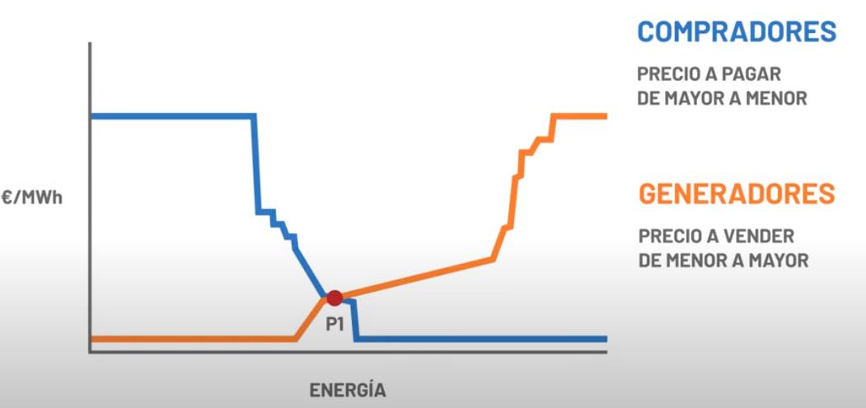

Important Notes:

* *Benefits:* rewards electricity generators with lowest cost (renewables and, if fully depreciated, nuclear), as they receive the highest margin. This encourages competition, innovation and allows small producers to remain in the market
* *Disadvantages:* volatility of price if cost of product CLOSE to equilibrium varies due to changing conditions → even though gas-based electricity generation only meets e.g.,15% of demand and has the highest price it sets the market price. When Gas prices spiked in 2022, electricity prices jumped extremely high even though the cost of renewables generated electricity stayed the same
* The market price is paid by the Commercializers to the energy producers, NOT the households
* The price agreed upon counts as the price for for same hour on the following day (so market price is set 24 hours in advance) → the market price for each hour of the day is established 24 hours in advance
* However, in the 24 hours in between setting the market price and executing on that price the price can be adjusted slightly (intraday pricing) depending on the demand/supply dynamics
* Finally, note that the regulators and system operators must ensure stability and reliability of the system, which means that the energy mix cannot be geographically and/or generation-type concentrated